|  |
| --- |
| Digital video aerial surveys of seabirds at Greater Gabbard Extension:  March 2020 to February 2021  Flight height analysis |
|  |
|  |

Authorisations

|  |  |  |  |
| --- | --- | --- | --- |
| **Responsibility** | **Name** | **Signature** | **Date** |
| Prepared by | Katharine Keogan & Ruth Peters-Grundy |  | 02/03/2021 |
| Checked by | Martin Scott | C:\Users\scottm\AppData\Local\Microsoft\Windows\INetCache\Content.Word\Martin Scott.tif | 02/03/2021 |
| Approved by | Andy Webb | C:\Users\irwinc\AppData\Local\Microsoft\Windows\Temporary Internet Files\Content.Outlook\KF2LA2XV\Signature (2).gif | 02/03/2021 |

Distribution List

|  |  |  |
| --- | --- | --- |
| **Name** | **Organisation** | **Email Address** |
| **Emma Ahart** | **SSE** | Emma.ahart@sse.com |

Document History

|  |  |  |
| --- | --- | --- |
| **Issue** | **Date** | **Status / Changes** |
| Draft 1 | 21/01/2021 | First draft for Client review |

Contents

Executive Summary 7

1 Introduction 8

2 Data collection methods 10

2.1 Survey flights 10

2.2 Data Review and Object Detection 10

2.2.1 Object Identification 11

2.3 Final processing 11

2.4 Data analysis 12

2.4.1 Data treatment 12

3 Flight height methods 13

3.1 Size-based flight height estimation method 13

3.1.1 Body lengths of birds with reflection 13

3.1.2 Body lengths of birds at height 14

3.2 Data presentation 16

4 Results 18

4.1 Survey effort 18

4.2 Flying birds 20

4.3 Flight height 23

4.3.1 Kittiwake 23

4.3.2 Lesser black-backed gull 31

4.3.3 Herring gull 38

5 Conclusions 44

5.1 Comparison with previous work 44

5.1.1 Kittiwake 44

5.1.2 Lesser black-backed gull 44

5.1.3 Herring gull 44

6 References 45

Tables

**Table 1** **Survey effort across the Greater Gabbard Extension survey area between March 2019 and February 2021 inclusive.** 18

Table 2 Total number of flying kittiwake measured and estimated within the survey area between March 2019 and February 2021 inclusive. 20

Table 2 Total number of flying lesser black-backed gull measured and estimated within the survey area between March 2019 and February 2021 inclusive. 21

Table 2 Total number of flying herring gull measured and estimated within the survey area between March 2019 and February 2021 inclusive. 22

Table 3 Mean height and proportion (%) of kittiwake at PCH between March 2019 and February 2020. For flight heights both the mean and the interquartile range (IQR), i.e. the middle 50% of the data, are reported for each of the bootstrapped flight height scenarios. 24

Table 4 Mean height and proportion (%) of kittiwake at PCH between March 2020 and February 2021. For flight heights both the mean and the interquartile range (IQR), i.e. the middle 50% of the data, are reported for each of the bootstrapped flight height scenarios. 26

**Table 3**  **Mean height and proportion (%) of lesser black-backed gull at PCH between March 2019 and February 2020. For flight heights both the mean and the interquartile range (IQR), i.e. the middle 50% of the data, are reported for each of the bootstrapped flight height scenarios.** 31

**Table 5**  **Mean height and proportion (%) of lesser black-backed gull at PCH between March 2020 and February 2021. For flight heights both the mean and the interquartile range (IQR), i.e. the middle 50% of the data, are reported for each of the bootstrapped flight height scenarios.** 33

**Table 3**  **Mean height and proportion (%) of herring gull at PCH between March 2019 and February 2020. For flight heights both the mean and the interquartile range (IQR), i.e. the middle 50% of the data, are reported for each of the bootstrapped flight height scenarios.** 38

**Table 5**  **Mean height and proportion (%) of herring gull at PCH between March 2020 and February 2021. For flight heights both the mean and the interquartile range (IQR), i.e. the middle 50% of the data, are reported for each of the bootstrapped flight height scenarios.** 40

Figures

**Figure 1 Example image of herring gulls in flight showing reflection from HiDef digital video**  **camera system.** 13

**Figure 2 Example of minimum and maximum height calculated for a single bird. Measurements are taken from multiple frames and, provided CV is less than 10%, only the maximum measured length is fed into flight height calculations.** 16

**Figure 3 Percentage of the example bird’s height range overlapping with turbine blades i.e. PCH. The black line represents the bird’s height range as calculated in Figure 2. The orange circle represents the turbine rotor area. The dotted red lines represent the PCH for a turbine (not to scale).** 16

**Figure 4 Map of completed flight transects within the Greater Gabbard Extension survey area between March 2020 and February 2021.** 19

**Figure 5 Distribution of kittiwake flight heights from minimum (2.5th percentile), mean and maximum (97.5th percentile) bootstrapped estimates between March 2019 and February 2021. The mean of the population for each distribution is indicated by the black dot, and the middle line represents the median. The grey boxes represent the middle 50% of the data. The dotted lines indicate the minimum and maximum rotor heights of both wind turbine scenarios.** 28

**Figure 7 Ordered height estimates of individual kittiwake in the survey area with minimum and maximum potential height range for both smallest and largest turbine specifications between March 2019 and February 2021.** 29

**Figure 9 Two-dimensional spatial variation in estimated mean flight heights of kittiwakes between March 2019 and February 2021. Flight height estimates were derived using an inverse distance weighted interpolation.** 30

**Figure 5 Distribution of lesser black-backed gull flight heights from minimum (2.5th percentile), mean and maximum (97.5th percentile) bootstrapped estimates between March 2019 and February 2021. The mean of the population for each distribution is indicated by the black dot, and the middle line represents the median. The grey boxes represent the middle 50% of the data. The dotted lines indicate the minimum and maximum rotor heights of both wind turbine scenarios.** 35

**Figure 7 Ordered height estimates of individual lesser black-backed gull in the survey area with minimum and maximum potential height range for both smallest and largest turbine specifications between March 2019 and February 2021.** 36

**Figure 9 Two-dimensional spatial variation in estimated mean flight heights of lesser black-backed gull between March 2019 and February 2021. Flight height estimates were derived using an inverse distance weighted interpolation.** 37

**Figure 5 Distribution of herring gull flight heights from minimum (2.5th percentile), mean and maximum (97.5th percentile) bootstrapped estimates between March 2019 and February 2021. The mean of the population for each distribution is indicated by the black dot, and the middle line represents the median. The grey boxes represent the middle 50% of the data. The dotted lines indicate the minimum and maximum rotor heights of both wind turbine scenarios.** 42

**Figure 9 Two-dimensional spatial variation in estimated mean flight heights of herring gull between March 2019 and February 2021. Flight height estimates were derived using an inverse distance weighted interpolation.** 43

Executive Summary

In February 2019, Innogy commissioned HiDef Aerial Surveying Limited (‘HiDef’) to undertake a programme of high-resolution digital video aerial surveys of marine megafauna, ornithological and human activity in support of the development proposals for the proposed Greater Gabbard wind farm extensions.

The Greater Gabbard wind farm is located approximately 23 km east of the Suffolk coast in the southern North Sea.

Monthly surveys were flown from March 2019 to February 2021, giving 24 surveys in total. HiDef designed a survey that placed transects at 2.5km apart across the survey area, including a 4km buffer around the proposed extension site (‘the survey area’).

The HiDef surveys were undertaken using an aircraft equipped with four (4) HiDef Gen II cameras with sensors set to a resolution of 2 centimetres (‘cm’) Ground Sample Distance (‘GSD’). Each camera sampled a strip of 125m width, separated from the next camera by ~25m, which provides a combined sampled width of 500m within a 575m overall strip. However, to ensure that sufficient footage is available to allow either a design-based or model-based analysis, footage from only two (2) of the four (4) cameras was analysed. The remaining footage has been archived. Surveys were successful in characterising the bird and mammal species present across the survey area, recording a total 45,332 birds of 18 species and 135 marine mammals of two species over two months.

This report presents the results from flight height analysis undertaken for three key species in the survey area: kittiwake *Rissa tridactyla*, lesser black-backed gull *Larus fuscus* and herring gull *Larus argentatus*.

Analysis was conducted on a wind turbine scenario with a rotor swept area of between 60m and 390m above Mean High Water Springs (MHWS). Based on the estimated mean flight heights of seabirds:

* 46.6% of gannets were flying at PCH in July (n = 874);
* 56.7% of gannets were flying at PCH in August (n = 552);
* 38.1% of kittiwakes were flying at PCH in July (n = 989);
* 27.4% of kittiwakes were flying at PCH in July (n = 1839)

# Introduction

1. Innogy operates the Greater Gabbard offshore wind farms with SSE as the leading developer. The wind farm is located off the English Suffolk coast and is 23km from the shore with 140 operational wind turbines. It is located close to its sister project of the Galloper Wind Farm.
2. In February 2019, Innogy commissioned HiDef Aerial Surveying Limited (‘HiDef’) to undertake a programme of high-resolution digital video aerial surveys of marine megafauna, ornithological and human activity in support of the development proposals for the proposed Greater Gabbard wind farm extensions.
3. HiDef designed the survey methodology to provide information suitable to make an accurate assessment of abundance and distribution of seabirds and marine mammals in order to enable an environmental impact assessment of the Greater Gabbard project. Surveys were conducted across both the Greater Gabbard extension proposed array area and a surrounding 16km buffer (hereafter ‘the survey area’).
4. A number of important bird sites which have been classified as Special Protection Areas (‘SPA’) under the European Council (‘EC’) Directive 2009/147/EC on the Conservation of Wild Birds (‘the Birds Directive’) are in the vicinity of the survey area. Alde-Ore Estuary SPA lies to the north west of the development site and is important for avocet *Recurvirostra avosetta*, redshank *Tringa totanus*, ruff *Calidris pugnax* and Sandwich tern *Sterna sandvicensis*. It is important both as a feeding and breeding area. The saltmarsh within the SPA is also important for nesting lesser black-backed gulls *Larus fuscus*. The latter has been flagged by nature conservation bodies as the main concern in relation to Greater Gabbard.
5. The Outer Thames SPA to the west of the survey area is designated for non-breeding red-throated diver *Gavia stellata* and is also in close proximity to the Greater Gabbard offshore wind farm. The site is also important for breeding common tern *Sterna hirundo* and little tern *Sternula albifrons* in summer.
6. Of these species, focus will particularly be upon lesser black-backed gulls, as with the previous studies of the project area and the neighbouring Galloper site. Concerns have also been highlighted regarding the potential displacement of guillemots *Uria aalge* and razorbills *Alca torda* at sea. Other migratory and transient bird species are also known to occur in the area, requiring year-round surveys to be carried to characterise their abundance.
7. In addition to assessing seabird abundance and distribution, flight height estimates are also required for species most at risk of collision with turbines.
8. Offshore windfarm developers undertake collision risk modelling (CRM) as part of their Environmental Impact Assessment (EIA). The impact assessment is likely to use the Band (2012) offshore CRM, or the stochastic version of this (McGregor *et al*. 2018). The offshore CRM has four options, with each differing in the use of flight height information. Option 1 uses site-based flight height information, but only uses the proportion of birds in flight as the input parameter. Option 2 similarly uses the proportion of birds in flight as the input parameter, but unlike Option 1 the data are derived from published generic flight height information (Johnston *et al*. 2014) rather than site-based information. Option 3 also uses generic flight heights, but unlike Options 1 and 2, it uses the distribution of the modelled flight height from Johnston *et al*. (2014). Option 4 (which is rarely, if ever, used) is similar to Option 3, but uses site-based flight height distribution data.
9. In most cases, consents of offshore wind farms in the UK have been supported by assessments using Option 2 and/or Option 3 results. Option 1 results have been mostly used as additional information and only used to provide context to the Option 2 and 3 results.
10. Site-based proportions of birds in flight at collision risk height can be derived from HiDef imagery using a size-based method, and this is suitable for Option 1 CRM for some species.
11. This report provides the results from size-based flight height analysis conducted for three key species using combined data from the 24 surveys undertaken between March 2019 and February 2021. This is a supplementary report and should be viewed in tandem with ‘the two-year report’ (‘HP00101-703-01).

# Data collection methods

## Survey flights

1. A series of strip transects was flown on a monthly basis between March 2019 and February 2021, following the protocol agreed in February 2019 (document reference: HP00101_001).
2. HiDef designed a survey that placed transects at 2.5 km apart across the survey area, which includes a 4 km buffer around the proposed Greater Gabbard Extension.
3. The strip transects were placed approximately perpendicular to the depth contours along the coast. Such a design helps to ensure that each transect samples a similar range of habitats (primarily relating to water depth) and will reduce the difference in bird and marine mammal abundance estimates for each transect.
4. Surveys were undertaken using an aircraft equipped with four (4) HiDef Gen II cameras with sensors set to a resolution of 2 cm Ground Sample Distance (GSD). Each camera sampled a strip of 125 m width, separated from the next camera by ~25 m, thus providing a combined sampled width of 500m within a 575 m overall strip.
5. To allow a 15% site coverage while ensuring an adequate number of transects, HiDef agreed with Innogy that only data from three (3) cameras would be processed for 9 months of data (March to September, December and February). For three winter surveys (October, November and January), however, 10% coverage was achieved over the site, HiDef agreed with Innogy that only data from two (2) cameras would be processed. Not only does this ensure that Innogy has a survey designed with sufficient coverage and number of transects, but it also offers the potential for the subsequent review and identification of additional data without undertaking additional survey, should unusual observations be made, or should additional counts be required.
6. The surveys were flown along the transect pattern at a height of approximately 550 m above sea level (ASL) (~1800’). Flying at this height ensures that there is no risk of flushing those species which have been proven to be easily disturbed by aircraft noise (Thaxter *et al*. 2016 recommends a minimum flight altitude of 500 m ASL).
7. Position data for the aircraft was captured from a Garmin GPSMap 296 receiver with differential GPS enabled to give 1m accuracy for the positions and recording updates in location at 1 second intervals for later matching to bird and marine mammal observations.

## Data Review and Object Detection

1. Data were viewed by trained reviewers who marked any objects in the footage as requiring further analysis, as well as determining which are birds, marine megafauna (defined within this report as cetaceans, pinnipeds or other large, non-avian marine fauna) or anthropogenic objects such as ships or buoys.
2. As part of HiDef’s quality assurance (QA) process, an additional ‘blind’ review of 20% of the raw data was carried out and the results compared with those of the original review. If 90% agreement is not attained during the QA process, then corrective action is initiated: the remaining data set is reviewed and where appropriate, the failed reviewer’s data discarded and all the data re-reviewed. In addition, additional training is then given to the reviewer to improve performance.
3. Objects are only recorded where it reaches a reference line (known as ‘the red line’) which defines the true transect width of 125 m for each camera. By excluding objects that do not cross the red line, biases to abundance estimates caused by flux (movement of objects in the video footage relative to the aircraft, such as ’wing wobble’) are eliminated.

### Object Identification

1. Images marked as requiring further analysis were reviewed by specialist ornithologists1 for identification to the lowest taxonomic level possible and for assessment of the approximate age and the sex of each animal, as well as any behaviour traits visible from the imagery.
2. At least 20% of all objects were subjected to an external QA process. If less than 10% disagreement is not attained then corrective action is initiated: if appropriate, the failed reviewer’s data is discarded and the data re-reviewed. Any disputed identifications are passed to a third-party expert ornithologist for a final decision[1].
3. All objects are assigned to a species group and where possible, each of these then further identified to species level. The species identifications are given a confidence rating of possible, probable or definite. Surfacing behaviour was defined as any surfacing behaviour that occurred while the non-avian animal was visible. However, for the purposes of calculating availability bias, harbour porpoise surfacing behaviour was also classified as if the animal’s dorsal fin was above the water in the frame nearest to the ‘red line’.

## Final processing

1. All observations were geo-referenced, taking into account the offset from the transect line of the cameras, and compiled into a single output; Geographical Information System (GIS) files for the Observation and Track data are issued in ArcGIS shapefile format, using UTM31N projection, WGS84 datum.

## Data analysis

### Data treatment

1. Data from the 12 surveys were kept separate in order to identify any seasonal variation in flight heights. Analysis was performed on the full survey area, including buffer, but can be further refined to just the survey area if required.
2. Flight height was then calculated for species which are deemed to be at risk from collision. This excludes auks and shearwaters which are known to maintain low flight heights. Typically, the species taken forward to collision risk modelling are gulls (including kittiwakes) and gannet.
3. Flight height analysis was calculated for three species which were deemed to be a priority in the southern North Sea: kittiwake *Rissa tridactyla*, lesser black-backed gull *Larus fuscus* and herring gull *Larus argentatus*. Species were selected based on their increased vulnerability to collision with wind turbine generators (WTGs) (Bradbury *et al*., 2014; Furness and Wade, 2013). All confidence levels of species identifications were used in the analysis.

# Flight height methods

## Size-based flight height estimation method

1. HiDef uses a size-based flight height estimation method calculated from digital video aerial footage. This is based on two key elements: measuring the body length of birds at known height and comparing this ‘baseline’ with measured body lengths at unknown height. To acquire body lengths of birds at known height, HiDef measures flying birds where reflections on the water surface are visible.
2. Images of birds that had already been positively identified were measured using a bespoke measurement tool (hereafter “RGB tool”). This tool extracts a range of measurements for each bird based on the variation across red, green and blue pixel values. This allows the uncertainty in the start and end point of the bird to be incorporated into the flight height estimate. A full description of the methodology is available in Humphries *et al.* (in prep).

Body lengths of birds with reflection

1. Known height body lengths are measured from birds that show this reflection in multiple frames of imagery. HiDef has calculated, using trigonometry, that birds showing reflection are flying at most 2.5 m above sea level.

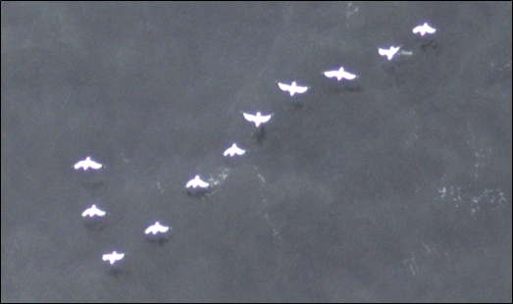**Figure 1 Example image of herring gulls in flight showing reflection from HiDef digital video camera system.**

1. HiDef uses a unique camera design, in which cameras are angled 30° from vertical to point away from the sun. Reflections only occur on the camera side of the bird being measured, and shadows only occur on the side of the bird away from the camera. Thus, there is 100% confidence that birds that are measured as having reflection are not mistaken for birds with shadows.
2. Since the presence of birds with reflection, and the height they are flying at, are not site-specific information HiDef has built a comprehensive database of birds in flight that show reflection and measured their body lengths. Thus, the sample size used to determine the range of body lengths of birds with low flight heights will increase with time as more data is added to the database. This is important, as only a relatively low proportion of birds observed show reflection (about 3%), as it seems to only occur under specific weather conditions. The sample sizes of birds with reflection obtained so far for gannet and kittiwake are 183 and 165.
3. For each bird captured on camera, multiple video frames are available; each video frame is measured, resulting in up to eight measurements per individual bird. Measurements are taken from the screen by trained analysts using a calibrated measurement tool (which uses the aircraft altitude). This measurement tool is able to reliably measure the length of the bird across the frame of the image and at angles across the horizontal/vertical pattern of pixels. The bird length is measured from the front of the head to the tip of the tail.
4. At times birds are contorted to the camera for various biological and behavioural reasons. They may be undertaking typical seabird shearing flight behaviour or plunge feeding into the sea. Notes are placed beside such behaviours so analysts can decide whether such images will provide measures which will not be accurate and would distort a flight height calculation if taken forward.
5. For each record (here a record is the individual bird, captured in one to eight frames) the coefficient of variation (CV) for body length is calculated. Where this CV is too high (an arbitrary threshold of 10% has been chosen) it may indicate a problem with the record. It may have an incorrectly measured (or transcribed) body length. To ensure that only high-quality data are used, records with a high CV are removed entirely.
6. From the multiple measurements in each record the maximum value is selected. The maximum value is used as the bird being measured cannot be smaller than the largest measurement taken. Data for all birds are then pooled and the upper and lower 2.5% of data are removed to remove any outliers in the distribution. The resulting upper and lower 95% values of the distribution are used as the minimum and maximum body length of a bird in flight at or near sea level (0 – 2.5 m).
7. It is important to note that smaller body lengths than the theoretical minimum (the smallest length the bird measured in the reflection database) do occur as birds are at an angle relative to the plane of the camera. The birds’ measured lengths are foreshortened in the image as noted in paragraph 31 above.

Body lengths of birds at height

1. For each survey body length measurements were taken of birds without reflections in the same way as those with reflections. Thus, only records with a CV across the frames less than 10% and the maximum measured length was used to calculate flight height.
2. The apparent body length of any one individual measured in these images will increase linearly with increasing proximity to the camera (e.g. a bird at half the distance between sea and the camera will be twice as large as a bird of the same size at the sea surface). Using this rationale, it is possible to use the proportional size of a bird at height to a bird at the sea surface (from reflection) multiplied against the altitude of the aircraft to determine the distance of the bird from the sea surface along the camera angle. To obtain a range of possible flight heights, the bootstrapped mean and 95% confidence intervals from birds at sea surface were compared to birds assumed to be at height or with no reflection (Equations 2, 3 & 4).

|  |  |
| --- | --- |
|  | (2) |
|  | (3) |
|  | (4) |

Where:

= Maximum flight height of a bird;

= Mean flight height of a bird;

= Minimum flight height of a bird;

= height of aircraft;

= Maximum length of individual bird;

= Upper 95 % CI of mean length of birds at sea surface;

= Mean length of birds at sea surface;

= Lower 95 % CI of mean length of birds at sea surface

1. The RGB tool generated a series of lengths for each frame. The mean values of the lengths in each frame were used to calculate the frame which had the largest mean length. Using the series of lengths in the frame with the highest mean length from the RGB tool, equations 2, 3 and 4 were applied which gave a series of possible minimum, mean and maximum flight heights. Each of these three flight height series were bootstrapped a further 5000 times to calculate the mean minimum, mean, and mean maximum possible flight heights, including their associated 95 % confidence limits. To generate the final range of possible flight heights, the minimum possible flight height was the lower 95% confidence interval from the bootstrapped minimum flight height series, while the maximum possible flight height was the upper 95% confidence interval from the bootstrapped maximum flight height series.

**Figure 2 Example of minimum and maximum height calculated for a single bird. Measurements are taken from multiple frames and, provided CV is less than 10%, only the maximum measured length is fed into flight height calculations.**

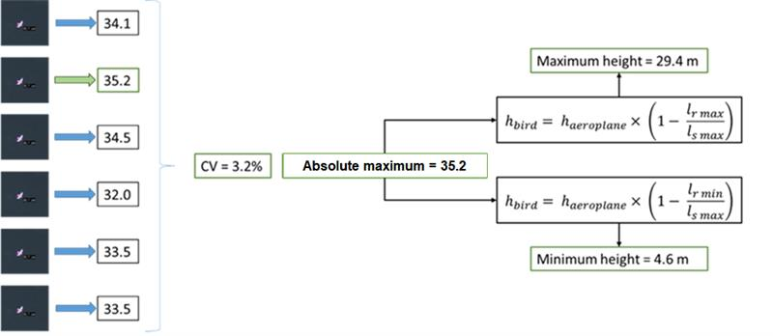

**Figure 3 Percentage of the example bird’s height range overlapping with turbine blades i.e. PCH. The black line represents the bird’s height range as calculated in Figure 2. The orange circle represents the turbine rotor area. The dotted red lines represent the PCH for a turbine (not to scale).**

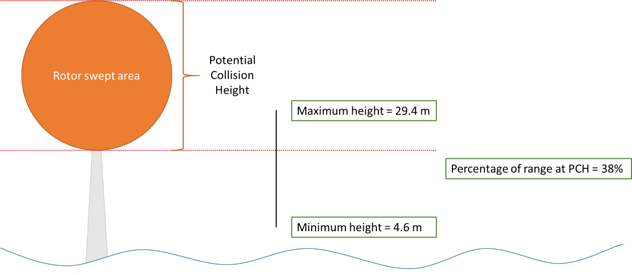

## Data presentation

1. Ordered flight height distribution plots were created to visualise these estimated height ranges. The 95 percent confidence limits around a bird’s flight height are indicated by coloured bars. Black dotted lines indicate the rotor swept area for each turbine scenario. The mean height of each individual bird is plotted in black. Mean heights that fall at 0m are an indication of birds flying very close to the sea surface.
2. An important parameter required for collision risk modelling is the proportion (Q2R) of birds flying within the potential collision height (PCH) band expressed as a percentage (Band 2012). To derive a site-based single figure estimate, the mean of each bird’s estimated flight height range was calculated. If this value fell within the rotor swept area, the bird was deemed to be at PCH and the overall percentage per species calculated.
3. Currently no exact turbine design or specification has been chosen for the development and a Rochdale Envelope approach has been taken to the development plan. As part of this approach the maximum and minimum specifications have been taken forward to show the two extremity case scenarios. Analysis of the proportion of birds at potential collision height (PCH) was calculated for both the largest and smallest WTGs in the scoping project envelope.
4. The largest WTGs have a maximum blade tip height of 322 m above Mean High Water Springs (MHWS) and a rotor diameter of 290 m giving a lower blade tip height of 32m above MHWS. The smallest WTGs have a maximum blade tip height of 252 m above MHWS and a rotor diameter of 220 m giving a lower blade tip height of 32 m above MHWS.
5. Ideally, turbine dimensions should be specified in m above Mean Sea Level (MSL), as bird heights are recorded relative to MSL. Maximum difference between MSL and MHWS for this site is unlikely to be very large, based on previous modelling at other sites. While this may change whether some individual birds fall within PCH but is unlikely to cause a significant difference. The calculations within this report were undertaken assuming turbine dimensions were provided in relation to MHWS.
6. Box plots were created to display the distributions of flight heights at minimum (2.5th percentile), mean and maximum (97.5th percentile) scenarios. The mean of the population was calculated using non-parametric bootstrapping (the mean of the bootstrapped means) and 95% confidence limits acquired.
7. HiDef recommends that these data are used in Option 1 collision estimates alongside generic data in decision-making, such as Johnston *et al*. (2014) in Option 2 or Option 3 of the Band (2012) model.
8. The method described here has been designed to be able to make use of biometric measurements from digital video images in order to estimate a range of possible flight heights of individual seabirds at sea at proposed offshore wind farms. HiDef has avoided using reference datasets based on museum skins or live birds measured in the hand, instead using a reference set of known height in which the length has been measured in the same way from digital video imagery as those of unknown height. HiDef considers that the use of this reference set helps to minimise any biases associated with size-based measurement of flying birds.
9. Because the latitude/longitude locations are known for the measured birds, they were plotted in space with the flight heights smoothed using an inverse distance weighted technique. This allowed for an assessment of the spatial variation in flight heights across a proposed wind farm area. Plots were generated in 2D and 3D space for ease of interpretation.

# Results

## Survey effort

1. The date, number of transects and survey effort (as expressed by length of transects) and transect route undertaken between March 2019 and February 2021 are shown in Table 1 and Figure 4. The number of transects and the total length of transects are those used in subsequent analysis.

**Table 1 Survey effort across the Greater Gabbard Extension survey area between March 2019 and February 2021 inclusive.**

| **Survey date** | **Survey Number** | **Number of transects analysed** | **Total length of transects analysed (km)** | **Area covered (km²)** |
| --- | --- | --- | --- | --- |
| 26 March 2019 | 1 | 16 | 304.36 | 114.14 |
| 5 April 2019 | 2 | 16 | 341.38 | 128.02 |
| 11 May 2019 | 3 | 16 | 304.30 | 114.11 |
| 6 June 2019 | 4 | 16 | 304.96 | 114.36 |
| 1 July 2019 | 5 | 16 | 305.19 | 114.45 |
| 28 August 2019 | 6 | 16 | 305.29 | 114.48 |
| 10 September 2019 | 7 | 16 | 306.30 | 114.86 |
| 5 October 2019 | 8 | 16 | 303.60 | 75.90 |
| 6 November 2019 | 9 | 16 | 328.68 | 82.17 |
| 23 December 2019 | 10 | 16 | 305.89 | 114.71 |
| 18 January 2020 | 11 | 16 | 335.25 | 83.81 |
| 14 February 2020 | 12 | 16 | 304.88 | 114.33 |
| 11 March 2020 | 13 |  | 307.01 | 115.13 |
| 9 April 2020 | 14 |  | 306.72 | 115.02 |
| 3 May 2020 | 15 |  | 330.83 | 124.06 |
| 20 June 2020 | 16 |  | 308.36 | 115.64 |
| 21 July 2020 | 17 |  | 308.00 | 115.50 |
| 5 August 2020 | 18 |  | 308.12 | 115.54 |
| 2 September 2020 | 19 |  | 308.42 | 115.66 |
| 9 October 2020 | 20 |  | 307.41 | 76.85 |
| 6 November 2020 | 21 |  | 307.41 | 76.85 |
| 15 December 2020 | 22 |  |  |  |
|  | 23 |  |  |  |
|  | 24 |  |  |  |

**Figure 4 Map of completed flight transects within the Greater Gabbard Extension survey area between March 2020 and February 2021.**

## Flying birds

1. The total number of flying birds measured within the survey area and those taken forward for flight height estimation are presented in Table 2, Table 3 and Table 4. A minimum number of 25 reflections is deemed suitable to run flight height analysis. The current sample size of reflection data for each equivalent species is presented alongside.

Any differences in the total number of birds measured and those presented in results will be due to removal of outlier values during the analysis process.

Table 2 Total number of flying kittiwake measured and estimated within the survey area between March 2019 and February 2021 inclusive.

|  |  |  |  |  |  |
| --- | --- | --- | --- | --- | --- |
| **Month** | **Measured birds (n)** | **Estimated flight heights (n)** | **Proportion estimated (%)** | **No. reflection birds** | **Sufficient reflection data?** |
| March 2019 |  |  |  |  |  |
| April 2019 |  |  |  |  |  |
| May 2019 |  |  |  |  |  |
| June 2019 |  |  |  |  |  |
| July 2019 |  |  |  |  |  |
| August 2019 |  |  |  |  |  |
| September 2019 |  |  |  |  |  |
| October 2019 |  |  |  |  |  |
| November 2019 |  |  |  |  |  |
| December 2019 |  |  |  |  |  |
| January 2020 |  |  |  |  |  |
| February 2020 |  |  |  |  |  |
| March 2020 |  |  |  |  |  |
| April 2020 |  |  |  |  |  |
| May 2020 |  |  |  |  |  |
| June 2020 |  |  |  |  |  |
| July 2020 |  |  |  |  |  |
| August 2020 |  |  |  |  |  |
| September 2020 |  |  |  |  |  |
| October 2020 |  |  |  |  |  |
| November 2020 |  |  |  |  |  |
| December 2020 |  |  |  |  |  |
| January 2021 |  |  |  |  |  |
| February 2021 |  |  |  |  |  |

Table 3 Total number of flying gannet measured and estimated within the survey area between March 2019 and February 2021 inclusive.

|  |  |  |  |  |  |
| --- | --- | --- | --- | --- | --- |
| **Month** | **Measured birds (n)** | **Estimated flight heights (n)** | **Proportion estimated (%)** | **No. reflection birds** | **Sufficient reflection data?** |
| March 2019 |  |  |  |  |  |
| April 2019 |  |  |  |  |  |
| May 2019 |  |  |  |  |  |
| June 2019 |  |  |  |  |  |
| July 2019 |  |  |  |  |  |
| August 2019 |  |  |  |  |  |
| September 2019 |  |  |  |  |  |
| October 2019 |  |  |  |  |  |
| November 2019 |  |  |  |  |  |
| December 2019 |  |  |  |  |  |
| January 2020 |  |  |  |  |  |
| February 2020 |  |  |  |  |  |
| March 2020 |  |  |  |  |  |
| April 2020 |  |  |  |  |  |
| May 2020 |  |  |  |  |  |
| June 2020 |  |  |  |  |  |
| July 2020 |  |  |  |  |  |
| August 2020 |  |  |  |  |  |
| September 2020 |  |  |  |  |  |
| October 2020 |  |  |  |  |  |
| November 2020 |  |  |  |  |  |
| December 2020 |  |  |  |  |  |
| January 2021 |  |  |  |  |  |
| February 2021 |  |  |  |  |  |

Table 4 Total number of flying lesser black-backed gull measured and estimated within the survey area between March 2019 and February 2021 inclusive.

|  |  |  |  |  |  |
| --- | --- | --- | --- | --- | --- |
| **Month** | **Measured birds (n)** | **Estimated flight heights (n)** | **Proportion estimated (%)** | **No. reflection birds** | **Sufficient reflection data?** |
| March 2019 |  |  |  |  |  |
| April 2019 |  |  |  |  |  |
| May 2019 |  |  |  |  |  |
| June 2019 |  |  |  |  |  |
| July 2019 |  |  |  |  |  |
| August 2019 |  |  |  |  |  |
| September 2019 |  |  |  |  |  |
| October 2019 |  |  |  |  |  |
| November 2019 |  |  |  |  |  |
| December 2019 |  |  |  |  |  |
| January 2020 |  |  |  |  |  |
| February 2020 |  |  |  |  |  |
| March 2020 |  |  |  |  |  |
| April 2020 |  |  |  |  |  |
| May 2020 |  |  |  |  |  |
| June 2020 |  |  |  |  |  |
| July 2020 |  |  |  |  |  |
| August 2020 |  |  |  |  |  |
| September 2020 |  |  |  |  |  |
| October 2020 |  |  |  |  |  |
| November 2020 |  |  |  |  |  |
| December 2020 |  |  |  |  |  |
| January 2021 |  |  |  |  |  |
| February 2021 |  |  |  |  |  |

Table 5 Total number of flying great black-backed gull measured and estimated within the survey area between March 2019 and February 2021 inclusive.

|  |  |  |  |  |  |
| --- | --- | --- | --- | --- | --- |
| **Month** | **Measured birds (n)** | **Estimated flight heights (n)** | **Proportion estimated (%)** | **No. reflection birds** | **Sufficient reflection data?** |
| March 2019 |  |  |  |  |  |
| April 2019 |  |  |  |  |  |
| May 2019 |  |  |  |  |  |
| June 2019 |  |  |  |  |  |
| July 2019 |  |  |  |  |  |
| August 2019 |  |  |  |  |  |
| September 2019 |  |  |  |  |  |
| October 2019 |  |  |  |  |  |
| November 2019 |  |  |  |  |  |
| December 2019 |  |  |  |  |  |
| January 2020 |  |  |  |  |  |
| February 2020 |  |  |  |  |  |
| March 2020 |  |  |  |  |  |
| April 2020 |  |  |  |  |  |
| May 2020 |  |  |  |  |  |
| June 2020 |  |  |  |  |  |
| July 2020 |  |  |  |  |  |
| August 2020 |  |  |  |  |  |
| September 2020 |  |  |  |  |  |
| October 2020 |  |  |  |  |  |
| November 2020 |  |  |  |  |  |
| December 2020 |  |  |  |  |  |
| January 2021 |  |  |  |  |  |
| February 2021 |  |  |  |  |  |

Table 6 Total number of flying herring gull measured and estimated within the survey area between March 2019 and February 2021 inclusive.

|  |  |  |  |  |  |
| --- | --- | --- | --- | --- | --- |
| **Month** | **Measured birds (n)** | **Estimated flight heights (n)** | **Proportion estimated (%)** | **No. reflection birds** | **Sufficient reflection data?** |
| March 2019 |  |  |  |  |  |
| April 2019 |  |  |  |  |  |
| May 2019 |  |  |  |  |  |
| June 2019 |  |  |  |  |  |
| July 2019 |  |  |  |  |  |
| August 2019 |  |  |  |  |  |
| September 2019 |  |  |  |  |  |
| October 2019 |  |  |  |  |  |
| November 2019 |  |  |  |  |  |
| December 2019 |  |  |  |  |  |
| January 2020 |  |  |  |  |  |
| February 2020 |  |  |  |  |  |
| March 2020 |  |  |  |  |  |
| April 2020 |  |  |  |  |  |
| May 2020 |  |  |  |  |  |
| June 2020 |  |  |  |  |  |
| July 2020 |  |  |  |  |  |
| August 2020 |  |  |  |  |  |
| September 2020 |  |  |  |  |  |
| October 2020 |  |  |  |  |  |
| November 2020 |  |  |  |  |  |
| December 2020 |  |  |  |  |  |
| January 2021 |  |  |  |  |  |
| February 2021 |  |  |  |  |  |

## Flight height

1. Estimates of mean flight height for the minimum, mean and maximum flight height scenarios are presented for each species in Tables X. The estimate of the proportion of birds at PCH for each scenario is based on the number of individual birds whose mean flight height fell within the rotor swept area.
2. The distribution of these heights are presented as box plots and ordered dot plots for each species in Figures X. The grey boxes represent the middle 50% of the estimated flight heights for each scenario, and the mean of the population is indicated by the black dot. The distributions of flight height are also represented in ordered dot plots in Figures X
3. The spatial variation in flight heights are represented in Figures X.
4. All but one of the mean heights for either of the two species ranged below 252m (the maximum rotor height of the smallest turbine specification). As such, the estimated proportions of birds at PCH for the smallest and largest wind turbine scenarios are identical with the exception of the maximum July flight height for gannets.

### Kittiwake

#### Proportion of birds at PCH

Table 5 Mean height and proportion (%) of kittiwake at PCH between March 2019 and February 2020. For flight heights both the mean and the interquartile range (IQR), i.e. the middle 50% of the data, are reported for each of the bootstrapped flight height scenarios.

| **Month** | **Sample size**  **(n)** | **Scenario** | **Mean of the bootstrap estimates (m)** | **±95% CI** | **IQR of bootstrapped estimates (m)** | **Proportion of birds at PCH**  **(%)** | |
| --- | --- | --- | --- | --- | --- | --- | --- |
| **Small scenario**  **(32 – 252m)** | **Large scenario**  **(32 – 322m)** |
| March 2019 |  | Minimum |  |  |  |  |  |
| Mean |  |  |  |  |  |
| Maximum |  |  |  |  |  |
| April 2019 |  | Minimum |  |  |  |  |  |
| Mean |  |  |  |  |  |
| Maximum |  |  |  |  |  |
| May 2019 |  | Minimum |  |  |  |  |  |
| Mean |  |  |  |  |  |
| Maximum |  |  |  |  |  |
| June 2019 |  | Minimum |  |  |  |  |  |
| Mean |  |  |  |  |  |
| Maximum |  |  |  |  |  |
| July 2019 |  | Minimum |  |  |  |  |  |
| Mean |  |  |  |  |  |
| Maximum |  |  |  |  |  |
| August 2019 |  | Minimum |  |  |  |  |  |
| Mean |  |  |  |  |  |
| Maximum |  |  |  |  |  |
| September 2019 |  | Minimum |  |  |  |  |  |
| Mean |  |  |  |  |  |
| Maximum |  |  |  |  |  |
| October 2019 |  | Minimum |  |  |  |  |  |
| Mean |  |  |  |  |  |
| Maximum |  |  |  |  |  |
| November 2019 |  | Minimum |  |  |  |  |  |
| Mean |  |  |  |  |  |
| Maximum |  |  |  |  |  |
| December 2019 |  | Minimum |  |  |  |  |  |
| Mean |  |  |  |  |  |
| Maximum |  |  |  |  |  |
| January 2020 |  | Minimum |  |  |  |  |  |
| Mean |  |  |  |  |  |
| Maximum |  |  |  |  |  |
| February 2020 |  | Minimum |  |  |  |  |  |
| Mean |  |  |  |  |  |
| Maximum |  |  |  |  |  |

Table 6 Mean height and proportion (%) of kittiwake at PCH between March 2020 and February 2021. For flight heights both the mean and the interquartile range (IQR), i.e. the middle 50% of the data, are reported for each of the bootstrapped flight height scenarios.

| **Month** | **Sample size**  **(n)** | **Scenario** | **Mean of the bootstrap estimates (m)** | **±95% CI** | **IQR of bootstrapped estimates (m)** | **Proportion of birds at PCH**  **(%)** | |
| --- | --- | --- | --- | --- | --- | --- | --- |
| **Small scenario**  **(32 – 252m)** | **Large scenario**  **(32 – 322m)** |
| March 2020 |  | Minimum |  |  |  |  |  |
| Mean |  |  |  |  |  |
| Maximum |  |  |  |  |  |
| April 2020 |  | Minimum |  |  |  |  |  |
| Mean |  |  |  |  |  |
| Maximum |  |  |  |  |  |
| May 2020 |  | Minimum |  |  |  |  |  |
| Mean |  |  |  |  |  |
| Maximum |  |  |  |  |  |
| June 2020 |  | Minimum |  |  |  |  |  |
| Mean |  |  |  |  |  |
| Maximum |  |  |  |  |  |
| July 2020 |  | Minimum |  |  |  |  |  |
| Mean |  |  |  |  |  |
| Maximum |  |  |  |  |  |
| August 2020 |  | Minimum |  |  |  |  |  |
| Mean |  |  |  |  |  |
| Maximum |  |  |  |  |  |
| September 2020 |  | Minimum |  |  |  |  |  |
| Mean |  |  |  |  |  |
| Maximum |  |  |  |  |  |
| October 2020 |  | Minimum |  |  |  |  |  |
| Mean |  |  |  |  |  |
| Maximum |  |  |  |  |  |
| November 2020 |  | Minimum |  |  |  |  |  |
| Mean |  |  |  |  |  |
| Maximum |  |  |  |  |  |
| December 2020 |  | Minimum |  |  |  |  |  |
| Mean |  |  |  |  |  |
| Maximum |  |  |  |  |  |
| January 2021 |  | Minimum |  |  |  |  |  |
| Mean |  |  |  |  |  |
| Maximum |  |  |  |  |  |
| February 2021 |  | Minimum |  |  |  |  |  |
| Mean |  |  |  |  |  |
| Maximum |  |  |  |  |  |

#### Flight height ranges

1. For interpretation of the following graphs, see Section 3.2.

**Figure 5 Distribution of kittiwake flight heights from minimum (2.5th percentile), mean and maximum (97.5th percentile) bootstrapped estimates between March 2019 and February 2021. The mean of the population for each distribution is indicated by the black dot, and the middle line represents the median. The grey boxes represent the middle 50% of the data. The dotted lines indicate the minimum and maximum rotor heights of both wind turbine scenarios.**

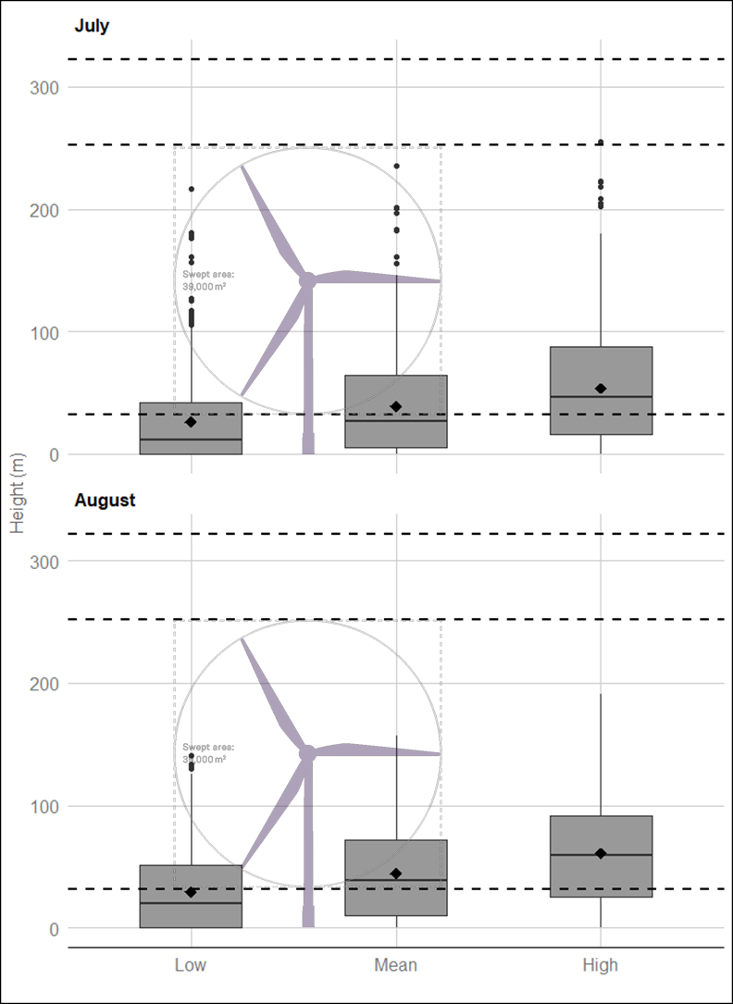

**Figure 6 Ordered height estimates of individual kittiwake in the survey area with minimum and maximum potential height range for both smallest and largest turbine specifications between March 2019 and February 2021.**

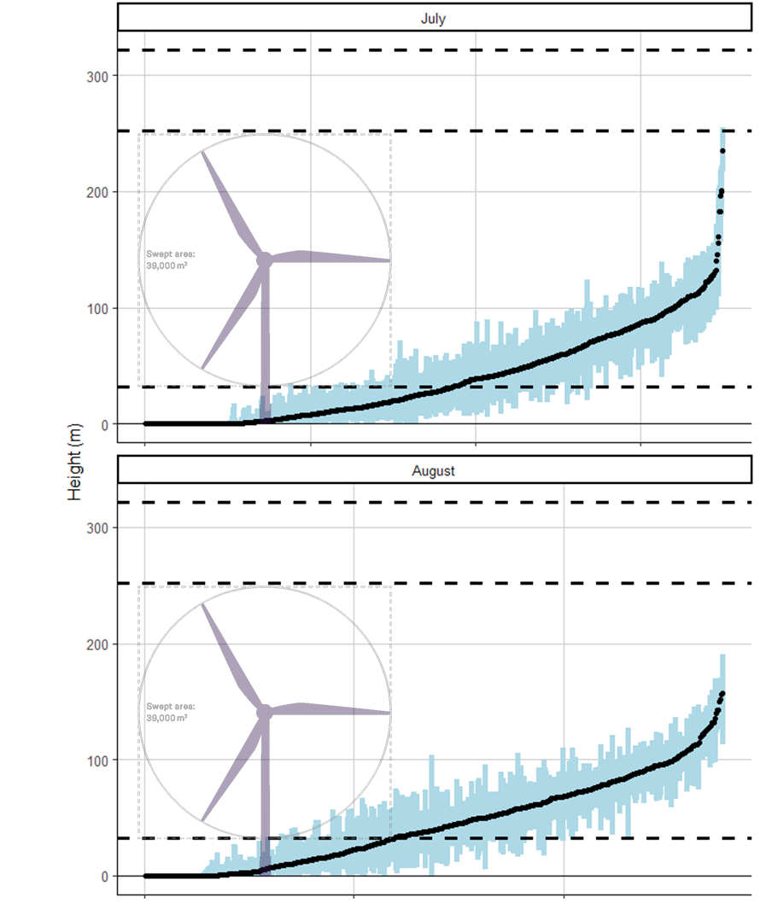

#### Spatial variation in flight height

1. The spatial variation in flight heights for kittiwake are presented in Figure 7. For interpretation of the following graphs, see Section 3.2.

**Figure 7 Two-dimensional spatial variation in estimated mean flight heights of kittiwakes between March 2019 and February 2021. Flight height estimates were derived using an inverse distance weighted interpolation.**

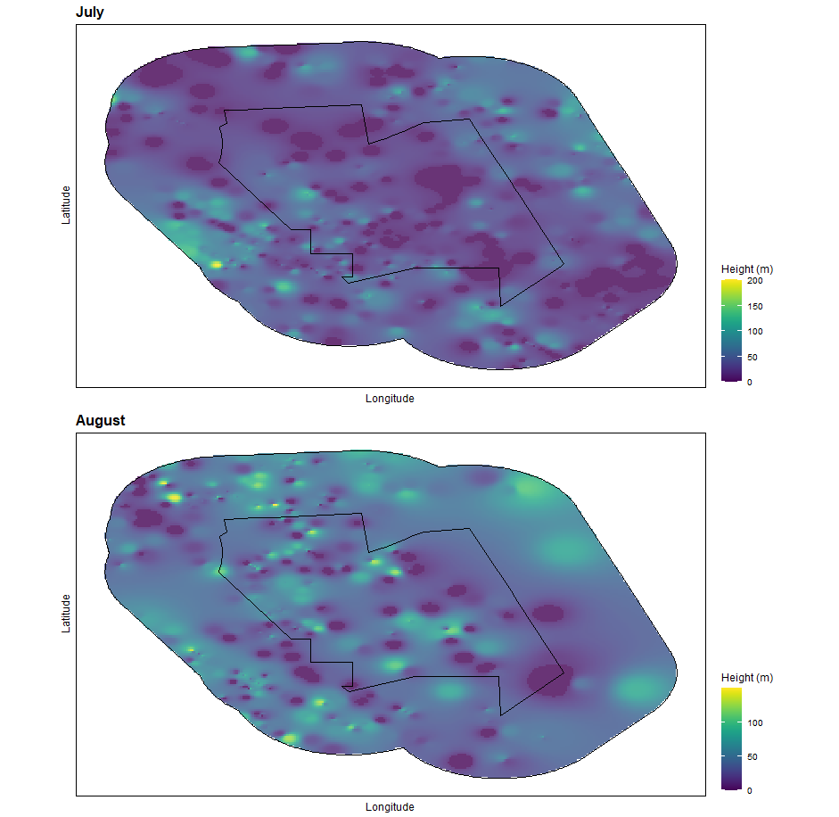

### Gannet

#### Proportion of birds at PCH

Table 5 Mean height and proportion (%) of gannet at PCH between March 2019 and February 2020. For flight heights both the mean and the interquartile range (IQR), i.e. the middle 50% of the data, are reported for each of the bootstrapped flight height scenarios.

| **Month** | **Sample size**  **(n)** | **Scenario** | **Mean of the bootstrap estimates (m)** | **±95% CI** | **IQR of bootstrapped estimates (m)** | **Proportion of birds at PCH**  **(%)** | |
| --- | --- | --- | --- | --- | --- | --- | --- |
| **Small scenario**  **(32 – 252m)** | **Large scenario**  **(32 – 322m)** |
| March 2019 |  | Minimum |  |  |  |  |  |
| Mean |  |  |  |  |  |
| Maximum |  |  |  |  |  |
| April 2019 |  | Minimum |  |  |  |  |  |
| Mean |  |  |  |  |  |
| Maximum |  |  |  |  |  |
| May 2019 |  | Minimum |  |  |  |  |  |
| Mean |  |  |  |  |  |
| Maximum |  |  |  |  |  |
| June 2019 |  | Minimum |  |  |  |  |  |
| Mean |  |  |  |  |  |
| Maximum |  |  |  |  |  |
| July 2019 |  | Minimum |  |  |  |  |  |
| Mean |  |  |  |  |  |
| Maximum |  |  |  |  |  |
| August 2019 |  | Minimum |  |  |  |  |  |
| Mean |  |  |  |  |  |
| Maximum |  |  |  |  |  |
| September 2019 |  | Minimum |  |  |  |  |  |
| Mean |  |  |  |  |  |
| Maximum |  |  |  |  |  |
| October 2019 |  | Minimum |  |  |  |  |  |
| Mean |  |  |  |  |  |
| Maximum |  |  |  |  |  |
| November 2019 |  | Minimum |  |  |  |  |  |
| Mean |  |  |  |  |  |
| Maximum |  |  |  |  |  |
| December 2019 |  | Minimum |  |  |  |  |  |
| Mean |  |  |  |  |  |
| Maximum |  |  |  |  |  |
| January 2020 |  | Minimum |  |  |  |  |  |
| Mean |  |  |  |  |  |
| Maximum |  |  |  |  |  |
| February 2020 |  | Minimum |  |  |  |  |  |
| Mean |  |  |  |  |  |
| Maximum |  |  |  |  |  |

Table 6 Mean height and proportion (%) of gannet at PCH between March 2020 and February 2021. For flight heights both the mean and the interquartile range (IQR), i.e. the middle 50% of the data, are reported for each of the bootstrapped flight height scenarios.

| **Month** | **Sample size**  **(n)** | **Scenario** | **Mean of the bootstrap estimates (m)** | **±95% CI** | **IQR of bootstrapped estimates (m)** | **Proportion of birds at PCH**  **(%)** | |
| --- | --- | --- | --- | --- | --- | --- | --- |
| **Small scenario**  **(32 – 252m)** | **Large scenario**  **(32 – 322m)** |
| March 2020 |  | Minimum |  |  |  |  |  |
| Mean |  |  |  |  |  |
| Maximum |  |  |  |  |  |
| April 2020 |  | Minimum |  |  |  |  |  |
| Mean |  |  |  |  |  |
| Maximum |  |  |  |  |  |
| May 2020 |  | Minimum |  |  |  |  |  |
| Mean |  |  |  |  |  |
| Maximum |  |  |  |  |  |
| June 2020 |  | Minimum |  |  |  |  |  |
| Mean |  |  |  |  |  |
| Maximum |  |  |  |  |  |
| July 2020 |  | Minimum |  |  |  |  |  |
| Mean |  |  |  |  |  |
| Maximum |  |  |  |  |  |
| August 2020 |  | Minimum |  |  |  |  |  |
| Mean |  |  |  |  |  |
| Maximum |  |  |  |  |  |
| September 2020 |  | Minimum |  |  |  |  |  |
| Mean |  |  |  |  |  |
| Maximum |  |  |  |  |  |
| October 2020 |  | Minimum |  |  |  |  |  |
| Mean |  |  |  |  |  |
| Maximum |  |  |  |  |  |
| November 2020 |  | Minimum |  |  |  |  |  |
| Mean |  |  |  |  |  |
| Maximum |  |  |  |  |  |
| December 2020 |  | Minimum |  |  |  |  |  |
| Mean |  |  |  |  |  |
| Maximum |  |  |  |  |  |
| January 2021 |  | Minimum |  |  |  |  |  |
| Mean |  |  |  |  |  |
| Maximum |  |  |  |  |  |
| February 2021 |  | Minimum |  |  |  |  |  |
| Mean |  |  |  |  |  |
| Maximum |  |  |  |  |  |

#### Flight height ranges

1. For interpretation of the following graphs, see Section 3.2.

**Figure 5 Distribution of gannet flight heights from minimum (2.5th percentile), mean and maximum (97.5th percentile) bootstrapped estimates between March 2019 and February 2021. The mean of the population for each distribution is indicated by the black dot, and the middle line represents the median. The grey boxes represent the middle 50% of the data. The dotted lines indicate the minimum and maximum rotor heights of both wind turbine scenarios.**



**Figure 6 Ordered height estimates of individual gannet in the survey area with minimum and maximum potential height range for both smallest and largest turbine specifications between March 2019 and February 2021.**



#### Spatial variation in flight height

1. The spatial variation in flight heights for gannet are presented in Figure 7. For interpretation of the following graphs, see Section 3.2. s

**Figure 7 Two-dimensional spatial variation in estimated mean flight heights of gannets between March 2019 and February 2021. Flight height estimates were derived using an inverse distance weighted interpolation.**



### Lesser black-backed gull

#### Proportion of birds at PCH

**Table 7 Mean height and proportion (%) of lesser black-backed gull at PCH between March 2019 and February 2020. For flight heights both the mean and the interquartile range (IQR), i.e. the middle 50% of the data, are reported for each of the bootstrapped flight height scenarios.**

| **Month** | **Sample size**  **(n)** | **Scenario** | **Mean of the bootstrap estimates (m)** | **±95% CI** | **IQR of bootstrapped estimates (m)** | **Proportion of birds at PCH**  **(%)** | |
| --- | --- | --- | --- | --- | --- | --- | --- |
| **Small scenario**  **(32 – 252m)** | **Large scenario**  **(32 – 322m)** |
| March 2019 |  | Minimum |  |  |  |  |  |
| Mean |  |  |  |  |  |
| Maximum |  |  |  |  |  |
| April 2019 |  | Minimum |  |  |  |  |  |
| Mean |  |  |  |  |  |
| Maximum |  |  |  |  |  |
| May 2019 |  | Minimum |  |  |  |  |  |
| Mean |  |  |  |  |  |
| Maximum |  |  |  |  |  |
| June 2019 |  | Minimum |  |  |  |  |  |
| Mean |  |  |  |  |  |
| Maximum |  |  |  |  |  |
| July 2019 |  | Minimum |  |  |  |  |  |
| Mean |  |  |  |  |  |
| Maximum |  |  |  |  |  |
| August 2019 |  | Minimum |  |  |  |  |  |
| Mean |  |  |  |  |  |
| Maximum |  |  |  |  |  |
| September 2019 |  | Minimum |  |  |  |  |  |
| Mean |  |  |  |  |  |
| Maximum |  |  |  |  |  |
| October 2019 |  | Minimum |  |  |  |  |  |
| Mean |  |  |  |  |  |
| Maximum |  |  |  |  |  |
| November 2019 |  | Minimum |  |  |  |  |  |
| Mean |  |  |  |  |  |
| Maximum |  |  |  |  |  |
| December 2019 |  | Minimum |  |  |  |  |  |
| Mean |  |  |  |  |  |
| Maximum |  |  |  |  |  |
| January 2020 |  | Minimum |  |  |  |  |  |
| Mean |  |  |  |  |  |
| Maximum |  |  |  |  |  |
| February 2020 |  | Minimum |  |  |  |  |  |
| Mean |  |  |  |  |  |
| Maximum |  |  |  |  |  |

**Table 8 Mean height and proportion (%) of lesser black-backed gull at PCH between March 2020 and February 2021. For flight heights both the mean and the interquartile range (IQR), i.e. the middle 50% of the data, are reported for each of the bootstrapped flight height scenarios.**

| **Month** | **Sample size**  **(n)** | **Scenario** | **Mean of the bootstrap estimates (m)** | **±95% CI** | **IQR of bootstrapped estimates (m)** | **Proportion of birds at PCH**  **(%)** | |
| --- | --- | --- | --- | --- | --- | --- | --- |
| **Small scenario**  **(32 – 252m)** | **Large scenario**  **(32 – 322m)** |
| March 2020 |  | Minimum |  |  |  |  |  |
| Mean |  |  |  |  |  |
| Maximum |  |  |  |  |  |
| April 2020 |  | Minimum |  |  |  |  |  |
| Mean |  |  |  |  |  |
| Maximum |  |  |  |  |  |
| May 2020 |  | Minimum |  |  |  |  |  |
| Mean |  |  |  |  |  |
| Maximum |  |  |  |  |  |
| June 2020 |  | Minimum |  |  |  |  |  |
| Mean |  |  |  |  |  |
| Maximum |  |  |  |  |  |
| July 2020 |  | Minimum |  |  |  |  |  |
| Mean |  |  |  |  |  |
| Maximum |  |  |  |  |  |
| August 2020 |  | Minimum |  |  |  |  |  |
| Mean |  |  |  |  |  |
| Maximum |  |  |  |  |  |
| September 2020 |  | Minimum |  |  |  |  |  |
| Mean |  |  |  |  |  |
| Maximum |  |  |  |  |  |
| October 2020 |  | Minimum |  |  |  |  |  |
| Mean |  |  |  |  |  |
| Maximum |  |  |  |  |  |
| November 2020 |  | Minimum |  |  |  |  |  |
| Mean |  |  |  |  |  |
| Maximum |  |  |  |  |  |
| December 2020 |  | Minimum |  |  |  |  |  |
| Mean |  |  |  |  |  |
| Maximum |  |  |  |  |  |
| January 2021 |  | Minimum |  |  |  |  |  |
| Mean |  |  |  |  |  |
| Maximum |  |  |  |  |  |
| February 2021 |  | Minimum |  |  |  |  |  |
| Mean |  |  |  |  |  |
| Maximum |  |  |  |  |  |

#### Flight height ranges

1. For interpretation of the following graphs, see Section 3.2.

Figure 8 Distribution of lesser black-backed gull flight heights from minimum (2.5th percentile), mean and maximum (97.5th percentile) bootstrapped estimates between March 2019 and February 2021. The mean of the population for each distribution is indicated by the black dot, and the middle line represents the median. The grey boxes represent the middle 50% of the data. The dotted lines indicate the minimum and maximum rotor heights of both wind turbine scenarios.

**Figure 9 Ordered height estimates of individual lesser black-backed gull in the survey area with minimum and maximum potential height range for both smallest and largest turbine specifications between March 2019 and February 2021.**

#### Spatial variation in flight height

1. The spatial variation in flight heights for lesser black-backed gull are presented in Figure 7. For interpretation of the following graphs, see Section 3.2.

**Figure 10 Two-dimensional spatial variation in estimated mean flight heights of lesser black-backed gull between March 2019 and February 2021. Flight height estimates were derived using an inverse distance weighted interpolation.**

### Great black-backed gull

#### Proportion of birds at PCH

Table 5 Mean height and proportion (%) of great black-backed gull at PCH between March 2019 and February 2020. For flight heights both the mean and the interquartile range (IQR), i.e. the middle 50% of the data, are reported for each of the bootstrapped flight height scenarios.

| **Month** | **Sample size**  **(n)** | **Scenario** | **Mean of the bootstrap estimates (m)** | **±95% CI** | **IQR of bootstrapped estimates (m)** | **Proportion of birds at PCH**  **(%)** | |
| --- | --- | --- | --- | --- | --- | --- | --- |
| **Small scenario**  **(32 – 252m)** | **Large scenario**  **(32 – 322m)** |
| March 2019 |  | Minimum |  |  |  |  |  |
| Mean |  |  |  |  |  |
| Maximum |  |  |  |  |  |
| April 2019 |  | Minimum |  |  |  |  |  |
| Mean |  |  |  |  |  |
| Maximum |  |  |  |  |  |
| May 2019 |  | Minimum |  |  |  |  |  |
| Mean |  |  |  |  |  |
| Maximum |  |  |  |  |  |
| June 2019 |  | Minimum |  |  |  |  |  |
| Mean |  |  |  |  |  |
| Maximum |  |  |  |  |  |
| July 2019 |  | Minimum |  |  |  |  |  |
| Mean |  |  |  |  |  |
| Maximum |  |  |  |  |  |
| August 2019 |  | Minimum |  |  |  |  |  |
| Mean |  |  |  |  |  |
| Maximum |  |  |  |  |  |
| September 2019 |  | Minimum |  |  |  |  |  |
| Mean |  |  |  |  |  |
| Maximum |  |  |  |  |  |
| October 2019 |  | Minimum |  |  |  |  |  |
| Mean |  |  |  |  |  |
| Maximum |  |  |  |  |  |
| November 2019 |  | Minimum |  |  |  |  |  |
| Mean |  |  |  |  |  |
| Maximum |  |  |  |  |  |
| December 2019 |  | Minimum |  |  |  |  |  |
| Mean |  |  |  |  |  |
| Maximum |  |  |  |  |  |
| January 2020 |  | Minimum |  |  |  |  |  |
| Mean |  |  |  |  |  |
| Maximum |  |  |  |  |  |
| February 2020 |  | Minimum |  |  |  |  |  |
| Mean |  |  |  |  |  |
| Maximum |  |  |  |  |  |

Table 6 Mean height and proportion (%) of great black-backed gull at PCH between March 2020 and February 2021. For flight heights both the mean and the interquartile range (IQR), i.e. the middle 50% of the data, are reported for each of the bootstrapped flight height scenarios.

| **Month** | **Sample size**  **(n)** | **Scenario** | **Mean of the bootstrap estimates (m)** | **±95% CI** | **IQR of bootstrapped estimates (m)** | **Proportion of birds at PCH**  **(%)** | |
| --- | --- | --- | --- | --- | --- | --- | --- |
| **Small scenario**  **(32 – 252m)** | **Large scenario**  **(32 – 322m)** |
| March 2020 |  | Minimum |  |  |  |  |  |
| Mean |  |  |  |  |  |
| Maximum |  |  |  |  |  |
| April 2020 |  | Minimum |  |  |  |  |  |
| Mean |  |  |  |  |  |
| Maximum |  |  |  |  |  |
| May 2020 |  | Minimum |  |  |  |  |  |
| Mean |  |  |  |  |  |
| Maximum |  |  |  |  |  |
| June 2020 |  | Minimum |  |  |  |  |  |
| Mean |  |  |  |  |  |
| Maximum |  |  |  |  |  |
| July 2020 |  | Minimum |  |  |  |  |  |
| Mean |  |  |  |  |  |
| Maximum |  |  |  |  |  |
| August 2020 |  | Minimum |  |  |  |  |  |
| Mean |  |  |  |  |  |
| Maximum |  |  |  |  |  |
| September 2020 |  | Minimum |  |  |  |  |  |
| Mean |  |  |  |  |  |
| Maximum |  |  |  |  |  |
| October 2020 |  | Minimum |  |  |  |  |  |
| Mean |  |  |  |  |  |
| Maximum |  |  |  |  |  |
| November 2020 |  | Minimum |  |  |  |  |  |
| Mean |  |  |  |  |  |
| Maximum |  |  |  |  |  |
| December 2020 |  | Minimum |  |  |  |  |  |
| Mean |  |  |  |  |  |
| Maximum |  |  |  |  |  |
| January 2021 |  | Minimum |  |  |  |  |  |
| Mean |  |  |  |  |  |
| Maximum |  |  |  |  |  |
| February 2021 |  | Minimum |  |  |  |  |  |
| Mean |  |  |  |  |  |
| Maximum |  |  |  |  |  |

#### Flight height ranges

1. For interpretation of the following graphs, see Section 3.2.

**Figure 5 Distribution of great black-backed gull flight heights from minimum (2.5th percentile), mean and maximum (97.5th percentile) bootstrapped estimates between March 2019 and February 2021. The mean of the population for each distribution is indicated by the black dot, and the middle line represents the median. The grey boxes represent the middle 50% of the data. The dotted lines indicate the minimum and maximum rotor heights of both wind turbine scenarios.**



**Figure 6 Ordered height estimates of individual great black-backed gull in the survey area with minimum and maximum potential height range for both smallest and largest turbine specifications between March 2019 and February 2021.**



#### Spatial variation in flight height

1. The spatial variation in flight heights for great black-backed gull are presented in Figure 7. For interpretation of the following graphs, see Section 3.2.

**Figure 7 Two-dimensional spatial variation in estimated mean flight heights of great black-backed gull between March 2019 and February 2021. Flight height estimates were derived using an inverse distance weighted interpolation.**



### Herring gull

#### Proportion of birds at PCH

**Table 9 Mean height and proportion (%) of herring gull at PCH between March 2019 and February 2020. For flight heights both the mean and the interquartile range (IQR), i.e. the middle 50% of the data, are reported for each of the bootstrapped flight height scenarios.**

| **Month** | **Sample size**  **(n)** | **Scenario** | **Mean of the bootstrap estimates (m)** | **±95% CI** | **IQR of bootstrapped estimates (m)** | **Proportion of birds at PCH**  **(%)** | |
| --- | --- | --- | --- | --- | --- | --- | --- |
| **Small scenario**  **(32 – 252m)** | **Large scenario**  **(32 – 322m)** |
| March 2019 |  | Minimum |  |  |  |  |  |
| Mean |  |  |  |  |  |
| Maximum |  |  |  |  |  |
| April 2019 |  | Minimum |  |  |  |  |  |
| Mean |  |  |  |  |  |
| Maximum |  |  |  |  |  |
| May 2019 |  | Minimum |  |  |  |  |  |
| Mean |  |  |  |  |  |
| Maximum |  |  |  |  |  |
| June 2019 |  | Minimum |  |  |  |  |  |
| Mean |  |  |  |  |  |
| Maximum |  |  |  |  |  |
| July 2019 |  | Minimum |  |  |  |  |  |
| Mean |  |  |  |  |  |
| Maximum |  |  |  |  |  |
| August 2019 |  | Minimum |  |  |  |  |  |
| Mean |  |  |  |  |  |
| Maximum |  |  |  |  |  |
| September 2019 |  | Minimum |  |  |  |  |  |
| Mean |  |  |  |  |  |
| Maximum |  |  |  |  |  |
| October 2019 |  | Minimum |  |  |  |  |  |
| Mean |  |  |  |  |  |
| Maximum |  |  |  |  |  |
| November 2019 |  | Minimum |  |  |  |  |  |
| Mean |  |  |  |  |  |
| Maximum |  |  |  |  |  |
| December 2019 |  | Minimum |  |  |  |  |  |
| Mean |  |  |  |  |  |
| Maximum |  |  |  |  |  |
| January 2020 |  | Minimum |  |  |  |  |  |
| Mean |  |  |  |  |  |
| Maximum |  |  |  |  |  |
| February 2020 |  | Minimum |  |  |  |  |  |
| Mean |  |  |  |  |  |
| Maximum |  |  |  |  |  |

**Table 10 Mean height and proportion (%) of herring gull at PCH between March 2020 and February 2021. For flight heights both the mean and the interquartile range (IQR), i.e. the middle 50% of the data, are reported for each of the bootstrapped flight height scenarios.**

| **Month** | **Sample size**  **(n)** | **Scenario** | **Mean of the bootstrap estimates (m)** | **±95% CI** | **IQR of bootstrapped estimates (m)** | **Proportion of birds at PCH**  **(%)** | |
| --- | --- | --- | --- | --- | --- | --- | --- |
| **Small scenario**  **(32 – 252m)** | **Large scenario**  **(32 – 322m)** |
| March 2020 |  | Minimum |  |  |  |  |  |
| Mean |  |  |  |  |  |
| Maximum |  |  |  |  |  |
| April 2020 |  | Minimum |  |  |  |  |  |
| Mean |  |  |  |  |  |
| Maximum |  |  |  |  |  |
| May 2020 |  | Minimum |  |  |  |  |  |
| Mean |  |  |  |  |  |
| Maximum |  |  |  |  |  |
| June 2020 |  | Minimum |  |  |  |  |  |
| Mean |  |  |  |  |  |
| Maximum |  |  |  |  |  |
| July 2020 |  | Minimum |  |  |  |  |  |
| Mean |  |  |  |  |  |
| Maximum |  |  |  |  |  |
| August 2020 |  | Minimum |  |  |  |  |  |
| Mean |  |  |  |  |  |
| Maximum |  |  |  |  |  |
| September 2020 |  | Minimum |  |  |  |  |  |
| Mean |  |  |  |  |  |
| Maximum |  |  |  |  |  |
| October 2020 |  | Minimum |  |  |  |  |  |
| Mean |  |  |  |  |  |
| Maximum |  |  |  |  |  |
| November 2020 |  | Minimum |  |  |  |  |  |
| Mean |  |  |  |  |  |
| Maximum |  |  |  |  |  |
| December 2020 |  | Minimum |  |  |  |  |  |
| Mean |  |  |  |  |  |
| Maximum |  |  |  |  |  |
| January 2021 |  | Minimum |  |  |  |  |  |
| Mean |  |  |  |  |  |
| Maximum |  |  |  |  |  |
| February 2021 |  | Minimum |  |  |  |  |  |
| Mean |  |  |  |  |  |
| Maximum |  |  |  |  |  |

#### Flight height ranges

1. For interpretation of the following graphs, see Section 3.2.

Figure 11 Distribution of herring gull flight heights from minimum (2.5th percentile), mean and maximum (97.5th percentile) bootstrapped estimates between March 2019 and February 2021. The mean of the population for each distribution is indicated by the black dot, and the middle line represents the median. The grey boxes represent the middle 50% of the data. The dotted lines indicate the minimum and maximum rotor heights of both wind turbine scenarios.

#### Spatial variation in flight height

1. The spatial variation in flight heights for herring gull are presented in Figure 7. For interpretation of the following graphs, see Section 3.2.

**Figure 12 Two-dimensional spatial variation in estimated mean flight heights of herring gull between March 2019 and February 2021. Flight height estimates were derived using an inverse distance weighted interpolation.**

# Conclusions

## Kittiwake

## Gannet

## Lesser black-backed gull

## Great black-backed gull

## Herring gull

# References

Band, W. 2012. Using a collision risk model to assess bird collision risks for offshore wind farms. Report to The Crown Estate Strategic Ornithological Support Services (SOSS), SOSS-02. http://www.bto.org/science/wetland-and-marine/soss/projects

Bradbury G., Trinder M., Furness B., Banks A.N., Caldow R.W.G., *et al.* 2014 Mapping Seabird Sensitivity to Offshore Wind Farms. PLoS ONE 9(9): e106366. doi:10.1371/journal.pone.0106366

Cleasby, I. R., Wakefield, E. D., Bearhop, S., Bodey, T. W., Votier, S. C., and Hamer. K. C., 2015. Three-dimensional tracking of a wide-ranging marine predator: flight heights and vulnerability to offshore wind farms. Journal of Applied Ecology **52**:1474–1482

Furness R.W., and Wade H., 2013. Vulnerability of Scottish seabirds to offshore wind turbines. Unpublished report to The Scottish Government, MacArthur Green Ltd, Glasgow.

Humphries, G.R.W., Fail, T., Watson, M., Bickley, D., Peters-Grundy, R., Scott, M., Webb., A. Aerial photogrammetry of seabirds from digital aerial video images using relative change in size to estimate flight height. *In preparation*.

Johnston, A., Cook, A.S.C.P., 2016. How high do birds fly? Development of methods and analysis of digital aerial data of seabird flight heights. BTO Research Report No. 676. Thetford.

Johnston, A., Cook, A.S.C.P., Wright, L.J., Humphreys, E.M. & Burton, N.H.K., 2014. Modelling flight heights of marine birds to more accurately assess collision risk with offshore wind turbines. Journal of Applied Ecology 51: 31–41.

Krijgsveld, K.L., R.C. Fijn, M Japink, P.W. van Horssen, C. Heunks, M.P. Collier, M.J.M. Poot, D. Beuker & S. Dirksen, 2011. Effect Studies Offshore Wind Farm Egmond aan Zee. Flux, flight altitude and behaviour of flying birds. Bureau Waardenburg report 10-219. Bureau Waardenburg, Culemborg.

McGregor, R.M., King, S., Donovan, C.R., Caneco, B. & Webb, A. 2018 A Stochastic Collision Risk Model for Seabirds in Flight. Report for Marine Scotland.

NIRAS. 2018. Hornsea Three Offshore Windfarm. Seabird Flight Height Trial Report. Appendix 5 to Deadline 2 Submission.

Thaxter, C. B., Ross-Smith, V. H., and Cook, A. S. C. P., 2016. How high do birds fly? A review of current datasets and an appraisal of current methodologies for collecting flight height data: Literature review. BTO Research Report No. 666.

1. HiDef currently employs three (3) of the ten (10) current members of the British Birds Rarities Committee (“BBRC”) as expert ornithologists